Personal information

Date of birth: 3-5-1980

Contact

**Address:**

Diyala – Baqubeh / Al-Rhma

**Phone:**

07735943761

**Email:**

[hanan6319@gmail.com](mailto:hanan6319@gmail.com)

[dr.hanan@bauc14.edu.iq](mailto:dr.hanan@bauc14.edu.iq)

**Research gate:**

<https://www.google.com/url?sa=t&source=web&rct=j&url=https://www.researchgate.net/profile/Hanan-Hassooni&ved=2ahUKEwie8f2FuJ30AhVJM-wKHQpHDwUQFnoECAMQAQ&usg=AOvVaw1lADkO4X_Q9a7Wijc1A9M7>

**Google Scholar:**

<https://scholar.google.com/citations?hl=ar&user=lWlp0W4AAAAJ>

Languages

Arabic

English

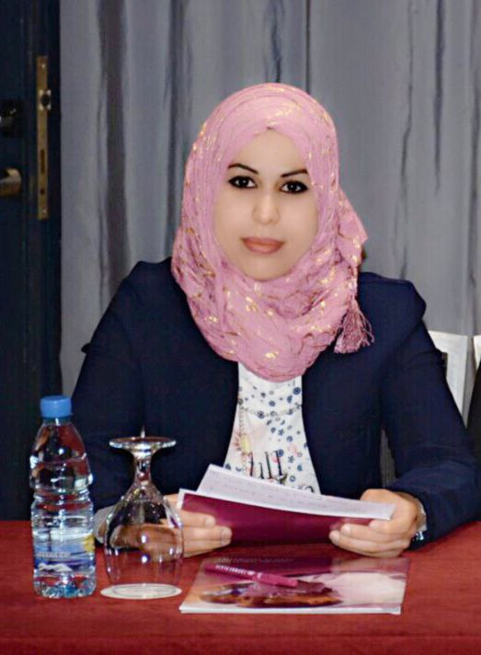

Hanan Raheem Hassooni

Summary

* I worked as a biology in the Teaching Laboratories - Baqubah Teaching Hospital for the period **2001-2012**.
* I worked as a doctor teacher in College of Education for Pure Sciences - University of Diyala **2019 -2020**.
* I work in the editorial team for a journal of ideas in health – Turkey

Education

* Bachelor's degree from College of Education for Pure Sciences / Department of biology 2008-2009.
* M.S.c in Parasitology
* PhD in Microbiology - Molecular Biology

Diyala University

Certifications

1. Teaching methods (2016)
2. Integrity of a language (2016)
3. The validity of teaching (2016)
4. Computer efficiency (2016)

Published research

1. Knowledge, attitude, and practice toward COVID-19 among Iraqi people: a web-based cross-sectional study‏/ Journal of Ideas in Health (2020)
2. Upper respiratory tract infection and otitis media are clinically and microbiologically associated‏ / Journal of Ideas in Health(2018)
3. Medical students carry more virulent microorganisms at their throat than that of patients' accompaniers‏ / Journal of Ideas in Health(2018)
4. Detection of Tn916 Conferring Tetracycline Resistance in Clinical Isolates of Streptococcus pyogenes / Indian Journal of Forensic Medicine & Toxicology(2021)

5. Detection of Trichomonas Vaginalis and its Relationship to Vaginal Microorganisms and Sex Hormones / Indian Journal of Public Health Research & Development (2020)

6. Detection of Tn917 Carrying erm (B) Gene in a Clinical Isolates of S. pyogenes / Indian Journal of Public Health Research & Development (2019)

7. Detection of Tn554 carrying erm (A) gene in a clinical isolates of S. pyogenes‏ / Annals of Tropical Medicine and Health (2019)

Practical activities

* دورة التدريب الاحترافي للتعليم الالكتروني المدمج للفترة بين 13 – 25 / 10/2020 (جامعة ديالى)
* دورة ادارة القاعة الامتحانية وتصميم نموذج اسئلة الكترونية للفترة بين 6-7 /4/2021
* دورة (Microsoft word and power point) للفترة بين 19-20/3/2021