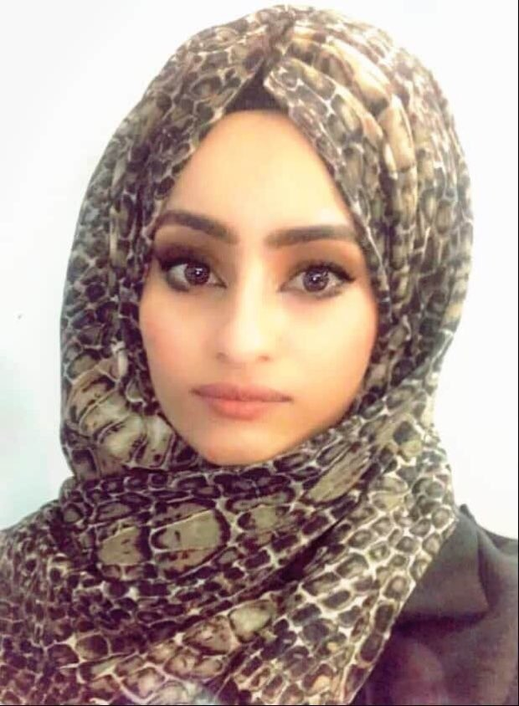  Personal Information  Hawraa Ali Mukhlif  Date of birth: 9-12-1992  Nationality: Iraq  Gender: Female  Marital status: Single  Driver license: Inter. & Iraqi  Contact Info.  Address: Iraq/ Diyala/Baqubah  Phone/ WhatsApp:  009647706888493  Email:  Hawraa22@bauc14.edu.iq  Research gate:  Google Scholar:  ORCID:  LANGUAGES  Arabic ●●●●●  English ●●●●◌ |  | WORK EXPERIENCE  Bilad Alrafidain University College/ Department of nursing 2021.  Experience  - I have experience working in hospital 2015.  - I have experience working in Higher Institute of Health /Diyala 2020  EDUCATION  - Bachelor Degree, College of Nursing/University of Baghdad 2014  - Master in community health nursing University of Baghdad 2019  SKILLS  - Computer drive experience  - Speaks English Language  RESEARCH FIELD  - Community Heath nursing (Nutrition Health, Epidemiological Health, School Health, occupational Health).  Certifications  - Certified from the First Virtual International Conference on COVID-19 Updates 2020.  - Certificate from Jordan Paramedic Society in the field of first aid 2020  - Certificate of participation on Oxygen Therapy for Healthcare Professionals from the University of Kufa 2020.  - Certified of participation on Update in Breast Diseases from the university of al Basra college of medicine 2020  - Certificate from Jordan Paramedic Society in the Infection Control Course 2020  PUBLICATIONS  Mukhlif, H. A., & Sajem, K. G. (2020). Evaluation of Intermediate Schools Female Students Adherence to Healthy Diet at Al-Russafa Sector in Baghdad City: Theory of Self-Efficacy as a Theoretical Framework. Indian Journal of Public Health Research & Development, 11(4).‏

