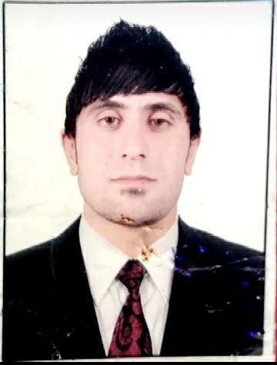
CV
ABDUL_HADI DHIAA MEHDI AL ANBAKI
PERSONAL INFORMATION
Nationality: Iraqi
Date of birth: 19/11/ 1991
Marital status: single
Address: Al_ Kalis, Diali, Iraq
E-Mail: abdulhadiphd91@gmail.com
Phone No: +918466032465, 07902974936
EDUCATION
1. Bachelor degree, University of Baghdad, College of Education
2. M.A English, Acharya Nagarjuna University, India
3. PH.D research scholar (English Literature), Acharya Nagarjuna University, India
Certification
1. English skills development certificate, Acharya Nagarjuna University, India
2. International Conference on Interdisciplinary Studies of Literature and Culture, Department of English, Andhra University, India
3. International Seminar on Social, Ethical and Cultural Values as Depicted in Drama, Department of English, Nannaya University, India
4. International Conference of (WMAW), Acharya Nagarjuna University
5. International Seminar on Women Entrepreneurship and Globalization: Issues and Challenges, Acharya Nagarjuna University
6. International Academic Conference on Languages and Cultures, Mahachulalon University, Thailand
7. Appreciate Certificate (British institute) arranged by University of Baghdad
8. M.A degree paper publication certificate, 2017.
9. Two papers publication certificates as one of PH.D study requirements in indexed international journals, 2019.

Work Experience
I have two year experience as a lecturer in English department, College of Arts, Acharya Nagarjuna University, India

